# Persistence of recruitment variability differences among co-occurring North Atlantic groundfish species

# Introduction

Patterns of recruitment and its variability are known to differ substantially among marine fish species, as well as depending on a variety of both intrinsic and extrinsic factors (e.g., Winemiller and Rose 1992, Spencer and Collie 1997, Houde 2016, Petrik et al 2021). Intrinsic factors such as the biomass and physiological condition of the spawning stock play a dominant role in determining recruitment success for many species, primarily those that are long-lived, iteroparous and attain large body sizes. Age and size structure, and the diversity of age structure, also play important roles in recruitment success given the demonstrated survival advantage that offspring from older, repeat spawners have over first time, smaller parents (Marshall 2009). Extrinsic factors involving environmental variability can influence recruitment success, more commonly among small bodied, semelparous, short lived species but can become more influential among larger-bodied species when exploitation effects cause a truncation of age structure and/or a reduction in stock biomass or body size. Recruitment and its relationship with the environment can therefore change over time, not only due to environmental changes but also due to phenotypic changes within the stock itself (Myers 1998; Brosset et al. 2020).

Some of the most perplexing patterns exist when seemingly closely related, sympatric species with similar life histories exhibit differential recruitment success and recruitment variability. Atlantic cod (*Gadus morhua*) and haddock (*Melanogrammus aeglefinus*) are gadoids found in shelf and coastal ecosystems in the western and eastern North Atlantic. The species have similar habitat requirements and overlap geographically, although cod extends further north and into colder waters on both sides of the Atlantic. Cod and haddock sustain large fisheries, often targeting both species in areas where they co-occur. Most stocks of these species have been overexploited historically. During the early 1990s, the cod and haddock fishery in the Northwest Atlantic collapsed, with landings less than 10% of historic maxima.

The decline of cod and haddock stocks motivated Fogarty et al (2001) to study the two species’ resilience to over-exploitation and their capacity for recovery from depletion, through a comparative analysis of the species reproductive capacity. Their study involved a comparative analysis of sympatric cod and haddock stocks in eight regions across the North Atlantic focusing on the quantification of recruitment variability and other reproductive parameters generated from theoretical stock and recruitment relationships. They found that haddock stocks exhibited consistently higher variability and lower reproductive rates compared to cod stocks in all of the geographic regions considered. This led the authors to conclude that cod have a higher resilience to overexploitation, but that depleted haddock stocks might be rescued by chance recruitments events and recover if strong year classes were protected from excessive exploitation.

Since Fogarty et al. (2001), the shelf ecosystems in the North Atlantic have changed and, in some instances, quite dramatically. These changes could have altered the patterns of recruitment variability and resilience to overfishing established by Fogarty et al (2001). Large-scale environmental warming trends have occurred in the shelf seas in the North Atlantic, with accelerated warming in the most recent decades (Garcia-Soto et al 2021). In the western Atlantic, fishing moratoria were introduced following stock collapses. These collapses were accompanied by ecosystem regime shifts and trophic cascades delaying or preventing stock recovery by altering trophic structure (Frank et al 2005). In the eastern Atlantic, the northernmost stocks located in the Barents Sea, have increased rapidly following reduction in fishing pressure and reached record high biomass levels.

Alongside the ecosystem changes, demographic structure of many cod and haddock stocks has changed. For instance, condition and size-at-age of cod and haddock on Scotian shelf has declined since the mid 1990’s and has remained low since then (Shackell and Frank 2007, Shackell et al 2010). In North Sea cod and haddock size and maturity at age has also declined (Baudron et al 2011, 2014, Marty et al 2014), and similar but not as dramatic declines in size and maturity at age have been observed for Icelandic cod (e.g. Pardoe et al 2009).

These well documented changes to the trophic structure, management regimes, and stock characteristics (spatial distributions, maturity, size and conditions at age), occurring in a warming ocean, may all impact recruitment variability of both cod and haddock, but not necessarily to the same extent or in the same direction throughout their range (Klein et al 2016, Fogarty et al 2008, Mantzouni et al 2010).

Here we update and extend the analysis conducted by Fogarty et al. (2001) utilizing model output from recent stock assessments to determine if the recruitment variability and reproductive rate differences among co-occurring North Atlantic cod and haddock have persisted. We divided the analysis into two periods – before and after 1993 with the former corresponding to the time period studied by Fogarty et al. (2001) and the latter associated with changes in the ecosystems, management regimes, stock characteristics and accelerated warming.

# Methods

## Data

We compiled recruitment estimates for cod and haddock stock pairs from the geographic areas that were similar to the ones evaluated by Fogarty et al (2001) (Table 1) with some exceptions. We added the Western Scotian Shelf and the Irish Sea areas, to replace the Brown’s Bank and West of Scotland regions. Haddock West of Scotland is no longer assessed as a separate stock, but instead is now assessed as part of the larger North Sea stock. Fogarty et al (2001) used data from the whole George Bank area, but we used the Eastern George Bank, since this allowed more updated time series.

The data was output from age-structured assessments of sympatric cod and haddock stocks conducted by the International Exploration of the Seas (ICES), Fisheries and Oceans Canada (DFO) and the Transboundary Resource Assessment Committee (TRAC). ICES reports with the latest available assessments were the source for the Northeast (NE) Atlantic stocks: Barents Sea cod and haddock (cod.27.1-2, had.27.1-2, ICES 2021a), Faroese cod and haddock (cod27.5.b.1, had.27.5.b, ICES 2020), Icelandic cod and haddock (cod.27.5.a, had.27.5.a ICES 2021b), Irish Sea cod (cod.27.7a, ICES 2013) and Irish Sea haddock (had.27.7a, ICES 2021c) and North Sea cod and haddock (cod cod.27.47d20, had.27.46a2, ICES 2021d). Regional stock and recruitment data for the Northwest (NW) Atlantic stocks of cod were obtained from the following sources: Eastern Scotian Shelf: Div. 4VsW (Mohn and Swain 2012), Western Scotian Shelf: Div. 4X5Y (DFO 2019), Eastern Georges Bank (Wang et al. 2015). For the NW Atlantic stocks of haddock, the sources were: Eastern Scotian Shelf: Div. 4VW (Mohn and Simon 2002), Western Scotian Shelf: Div. 4X5Y (Wang et al. 2017), Eastern Georges Bank (Stone et al. 2015). Age at recruitment varies among stocks (Table 1). We standardized age at recruitment within areas where stocks differed in recruitment age: Icelandic cod R3 was back-calculated to R2 by assuming M=0.2 and F=0. R0 for North Sea haddock was replaced with abundance at age 1 estimates from the assessment (ICES 2021). R1 for the Irish Sea haddock was calculated from R0 using discard estimates of F and assuming M=0.2 (ICES 2021).

## Analysis

Following the same approach as Fogarty et al (2001), recruitment variability was assessed by estimating the standard deviation of the residuals from a Ricker stock and recruitment model fitted to the SSB and recruitment from each stock. The Ricker model was linearized to:

Eq. 1 $log(\frac{R}{SSB})=log(a)+b×log(SSB)+ϵ_{i}$

where *R* is the number of recruits,*SSB* is the spawning stock biomass in the birth year of the recruits, *log(a*) is the intercept of the relationship, *b* is the slope, and is a normally distributed error term.

In keeping with the various lines of inquiry initiated by Fogarty et al. (2001), we quantified temporal autocorrelation in the recruitment residuals from the Ricker models, as well as the temporal correlation of the recruitment residuals between cod and haddock stocks within each region, The existence of significant negative autocorrelation implies inter-cohort intraspecific competition and/or cannibalism, whereas positive autocorrelation suggests persistent environmental forcing may be operative (Ricard et al 2016). A positive correlation between cod and haddock may imply that the two species are responding to environmental drivers in the same way whereas a negative correlation would suggest that interspecific competition, predation or that environmental drivers act to produce contrasting species-specific effects. . Given the uncertainty of the fitting of theoretical stock and recruitment relationships to data, we also quantified recruitment variability using a *model-free* approach using Generalized Additive Models (GAMS) which served to remove trends, potentially resulting from SSB, from the recruitment time series (on the log scale) for each stock. The standard deviation of the residuals from this *model-free* approach were used as a second metric of recruitment variability for each stock.

The parameter log(*a)* (Eq 1) is commonly referred to as the steepness parameter and provides an estimate of the number of recruits produced per unit SSB at low *SSB* levels (e.g. Wiff et 2018, Lowerre-Barbieri et al 2017). In addition, a *model-free* estimate of reproductive capacity at low SSB was calculated by taking the mean number of recruits per SSB when SSB was less than 40% of maximum SSB. The Ricker and model-free estimates of reproductive capacity at low SSB were then standardized so than they represented an estimate of the number of spawners produced by each spawner at low abundance, following Fogarty et al (2001) and Myers et al (1999), and are hereafter referred to as the maximum annual reproduction rates These parameters are an indicator of a stock’s ability to recover from collapse/depletion.

We chose to separate the analysis into two periods to facilitate a comparison with the results obtained by Fogarty et al. (2001) and to assess the possibility that there were differences in the observed patterns during the most recent period. Hence, the time series were split into a “*Pre 1993”* (years prior to and including 1992) period and a “*Recent”* period (1993-end of time series). In addition to facilitating a direct comparison with Fogarty et al. (2001), the early 1990s marked a point in time when many of the NW Atlantic stocks of cod and haddock either collapsed or reached a historical minimum (Shackell and Frank 2007, Frank et al. 2016).

# 3. Results

**3.1 Time trends in input data**

The time series were generally longer, for the NE Atlantic stocks compared to the NW Atlantic stocks (Table 1, Figure 1). The NW Atlantic stock are no longer assessed annually, and the Eastern Scotian Shelf haddock, once sustaining a substantial fishery, has not been assessed since 2001 (Table 1). The NE stocks, except the Irish Sea cod stock, are regularly assessed. The average time series length for the cod and haddock stocks from the NE Atlantic stocks was 59 (range:4 – 72) and 49 (range: 26 – 68) respectively. For the NW Atlantic stocks of cod and haddock the time series length was 36 (range : 33 – 39) and 34 (range; 28 – 45) respectively.

**3.1.1 Spawning Stock Biomass**

All cod SSB’s reached minimum levels after 2000, except the two Northernmost stocks, Icelandic and Barents Sea cod (1993 and 1965 respectively, Table 1, Figure 1). Maximum SSB was reached as early as 1955 for Icelandic cod, and was reached prior to the Recent period for all cod stocks except the Barents Sea cod peaking in 2013. The average SSB level across cod stocks was 35% lower in the Recent period compared to Pre-1993. The overall decline was driven by the Northwest Atlantic stocks where SSB was on average 72% lower, compared to 13% for the Northeast Atlantic stocks (Figure 1). During the Recent Period, some of the Northeast Atlantic stocks declined (Irish Sea, North Sea, Faroese), and some increased (Barents Sea and Iceland) (Figure 1), whereas in the Northwest Atlantic, the cod stocks either continued to decline or stayed at a low lever in the Recent Period (Figure 1).

Contrary to cod, all haddock SSBs peaked after 2000, except the Eastern Scotian shelf haddock which peaked in 1985. Minimum SSB levels were observed in the 1980’s for the Northernmost haddock stocks (Iceland and Barents Sea), during the 1970’s for Eastern Scotian Shelf and the Eastern Georges Bank haddock, and more recently for the Faroese and Western Scotian Shelf haddock (Table 1). Overall, SSB levels for haddock were 20% higher in the Recent period, this was more pronounced for the Northwest Atlantic stocks (40%) than the Northeast Atlantic stocks (10%).

Variability in SSB, based on the ratio of the maximum to minimum observed values in the time series, was lowest among the NE Atlantic haddock stocks (range: 4.4 – 10.7), followed by NE cod stocks (range: 6.3 – 20.9), NW Atlantic haddock stocks (range: 3.1 – 25.2) and NW cod stocks (range: 10 - 39).

**3.1.2 Recruitment**

For cod across all regions, the recruit numbers in the Recent period were on average 58% lower than the Pre-1993 period, in the NE Atlantic the decline was 49% while in the NW Atlantic this decline was much greater with declines in recruit numbers averaging 73% (Figure 2).

For haddock across all regions, the recruit numbers were 50% higher in the Recent period compared to the Pre-1993 period, in the Northeast Atlantic there was no difference in the average recruitment numbers between the two periods, while in the Northwest Atlantic the recruit numbers averaged 110% higher in the Recent period (Figure 2).

The correlation between the cod and haddock recruitment time series Pre-1993, was significantly positive for the North Sea, the Faroese and Barents Sea, positive but not significant for Iceland and the Eastern Scotian Shelf and the Eastern George Bank, and non-significantly but negative for the Western Scotian Shelf (Figure 3). The correlation between the cod and haddock recruitment tended to be positive also in the Recent period, but for all regions except for the North Sea and the Faroese, the correlation was not significant (Figure 3).

**3.2 Ricker model results**

The Ricker models explained only 27% of the variance between recruits and SSB on average, with no clear difference observed between the species, regions, or period (Table 2).

**3.2.1 Recruitment variability**

The standard deviation of the recruitment residuals was on average 80% higher for the haddock stocks than for the cod stocks in the Pre-1993 period (Figure 4, Table 2). In the Recent period, the standard deviation of the recruitment residuals was on average 70% higher (for the haddock stocks than for the cod stocks (Figure 4, Table 2), similar to the Pre-1993 period.

## 3.2.2 Residual Autocorrelation

The autocorrelation in recruitment residuals in the Pre-1993 tended to be positive for the Northeast Atlantic stocks (Figure 5). In the Northwest Atlantic, the more southern stocks tended to have a lower autocorrelation, with Eastern Georges Bank cod being the only stock in the analysis with negative residuals. The autocorrelation in recruitment residuals in the Recent period tended to be positive for the NE Atlantic stocks (Figure 5), similar to what was observed in the Pre-1993 period. In the NW Atlantic, the Eastern Georges Bank and Western Scotian Shelf stocks tended to be more negative and had larger uncertainties than most other stocks.

**3.2.3 Maximum Annual Reproduction Rate**

In the Pre-1993 period, the maximum annual reproduction rate at low SSB (i.e the standardized *log(a)* parameter in Ricker model) was higher for cod than for haddock in five of seven regions (no data from the Irish Sea) but only significantly so for three regions (confidence intervals not overlapping the 1:1 line for Barents Sea, North Sea and Eastern Scotian Shelf, Figure 6). In the Recent period, the maximum annual reproduction rate of the cod stocks was higher for five out of seven, but only significantly so for three stocks (Barents Sea, North Sea and Iceland, Figure 6). In addition, in the Recent period, the estimated maximum annual reproduction rate for the Northeast Atlantic stocks was higher for cod than haddock for all stocks, while the Northwest Atlantic stock results were more mixed, with the Western Scotian Shelf stock being the only stock in which the Haddock maximum annual reproduction rate was significantly higher than cod (Figure 9).**3.3 Model free results**

**3.3.1 Recruitment variability**

The results on recruitment variability from the gam models, measured as the standard deviation of the recruitment residuals showed that recruitment was more variable for haddock compared to cod, for both periods (Figure 7), and therefore very similar to the results based on the residuals from the from the Ricker model. The patterns of the autocorrelation in the recruitment residuals from gam model was also very similar to the autocorrelation in the Ricker residuals (Figure 5) and is shown in Supplement Figure 1.

**3.3.2 M**aximum Annual Reproduction Rate

The model free estimate of the maximum annual reproduction rate produced similar results to the Ricker model results. In the Pre 1993 period the maximum annual reproduction rate was higher for cod than it was for haddock for all 5 stocks in which this could be calculated. In the Recent period, the maximum annual reproduction rate for all the Northwest Atlantic stocks was similar or higher for Haddock than for Cod, while for the Northeast Atlantic stocks the maximum annual reproduction rate was higher for Cod (Figure 9).

# Discussion

Our results are similar to those obtained by Fogarty et al (2001), with recruitment variability being higher for haddock than for cod, both before and after 1993. This result was evident both for the period ~coinciding with the period covered by Fogarty et al (2001), for the more recent period and also for the whole time series available here (Supplement Figure 2). Also, the results were consistent using the standard deviation of the log transformed, but otherwise unadjusted recruitment series, the residuals from the Ricker models and the residuals from models where temporal trends where adjusted for using gams smooths. The difference between cod and haddock in recruitment variability thus appear robust across regions, time periods and methods used to measure recruitment variability.

In contrast, the results were more varied in terms of the maximum annual reproduction rate at low SSB. Fogarty et al (2001) found that maximum annual reproduction rate assessed from the Ricker model, was consistently and significantly higher for cod in all but one region (the Browns Bank). While the current study found that the maximum annual reproductive rate was higher for cod, these difference were typically not significant. The differences also appear to be less pronounced in the Recent time period, especially for stocks in the Northwest Atlantic region. The maximum annual reproduction rate results found in Fogarty et al (2001) thus appear less generalizable than the results related to recruitment variability.

Our estimates of first order autocorrelation recruitment residuals were similar to that of Fogarty et al (2001) and mostly small and positive, as also found by Ricard et al (2016), positive autocorrelation suggests similar environmental forcing from year to year. The correlations between recruitment series for sympatric cod and haddock stocks were also mainly non-significant and positive implying that within the same ecosystem, the environmental conditions had a similar (weak) effect on cod and haddock recruitment. Covariation in recruitment among species is not uncommon in the marine environment (Myers et al. 1997). For instance, in the Barents Sea, strong year classes of different species do coincide but tend to do so only in warm years (e.g. Dingsør et al 2007, Landa et al 2014). However, the effect of environmental drivers on recruitment is rarely stationary (Hidalgo et al 2012, Brosset et al 2020). In the Barents Sea during the recent anomalous warm years, the effect of temperature has become less important and the correlation between cod and haddock recruitment has weakened (this study, and Bogstad et al 2013).

Cod recruitment and the maximum reproductive rate is predicted to decline with warming at the southernmost distribution range (e.g. Fogarty et al 2008). A study comparing the impact of temperature on the maximum reproductive rate across all cod stocks found that temperature reduced reproductive potential when temperatures were above 5°C (Mantzouni et al 2010). Haddock has been found to perform physiologically better than cod in warmer conditions (Norin et al. 2019), but there are much fewer studies on the impact of warming on haddock compared to cod (Klein et al 2016). The only comparison of the effect temperature on maximum annual reproduction rate of cod and haddock is an unpublished study by Mantzouni and MacKenzie (2009), revealing an overall positive temperature effect of haddock, and a dome shaped relationship for cod. Although we did not find clear evidence of increase in maximum annual reproduction rate of haddock relative to cod in the Recent, warmer period, an overall increase in haddock recruitment and decline of cod recruitment was found, which is consistent with a more adverse effect of warming on cod than haddock.

Traits related to recruitment, include both fixed and variable traits that are responsive to changes in the environment, e.g. temperature over time (Lowerre-Barbieri et al 2017). We found that despite substantial and ongoing changes in the environment, our results confirmed the finding by Fogarty et al (2001) of the higher recruitment variability of haddock compared to cod. Likely therefore, there are fixed traits related to recruitment that vary between the two species rendering haddock more prone to recruitment variability.

Cod and haddock share many reproductive traits with each other, as well as other gadoids and also most other important commercial temperate water species: small pelagic eggs, larvae and early-stage juveniles, high egg production (Lowerre-Barbieri et al 2017) and batch spawning (Murua and Saborido-Rey 2003). Combined with a broad age structure with several reproductive age groups, these traits serve to buffer against environmental perturbation and, up to a point, against perturbations caused by fishing. Cod and haddock also share traits that have been used to classify fish species according to their susceptibility to overfishing, population dynamics and recruitment variability (e.g. Winemiller and Rose 1992). Still, they differ in traits driving recruitment variability, and unfortunately, it is often difficult to determine if reported differences among cod and haddock traits are due to species-specific traits or pertain only to the specific areas studied. For instance, Fogarty et al (2001) reported a more protracted spawning season and broader spatial extent of cod compared to haddock as an explanation of the difference in recruitment variability, but the evidence that exists from the Barents Sea suggests an opposite pattern (Bergstad et al 1987).

Traits that appear to be consistently different between the two species across areas are diet and maximum size. Adult haddock is more of a benthivore feeding on invertebrates such a brittle stars and polychaetes (Tam et al 2016) compared to cod, which is much more piscivorous and is prone to eating its own young (Link et al 2009). The cannibalistic behaviour can cause density dependence, that potentially stabilizes recruitment, by dampening the production of strong year classes before they reach fishable size. However, the degree of cod cannibalism varies substantially among ecosystems (Link et al 2009) and is unlikely to be important in areas where older, large cod have recently become rare, such as in the Northwest Atlantic stocks examined herein. The buffering of recruitment variability caused by traits related to body size of spawners (longer spawning season, more batches, larger and more eggs) are also likely to be reduced in areas where cod (and haddock) size has been severely depleted, and therefore not likely to explain the consistent pattern in recruitment variability evident here.

Could the relevant traits be found in differences between cod and haddock egg and larvae? Haddock eggshell (chorion) is sticky, this attribute has been used to differentiate between early stage eggs of cod and haddock (N: Mukhina pers comm). This chorion characteristic binds oil droplets, enhancing exposure to toxic compounds (Sørhus et al 2015), but probably also has some unknown adaptive significance that may impact recruitment variability, and in some circumstances increase recruitment success. Haddock larvae develop larger pectoral fins earlier than, improving their manoeuvrability (Auditore et al 1994, Petrik et al 2013), which might be of benefit under some instances but might also infer a cost. If these early life stage traits that has been found to differ between cod and haddock has impact on mortality of early life stages, these traits could create large differences in year class strength and recruitment variability.

We are unable to firmly conclude which traits are responsible for the difference in cod and haddock recruitment variability based on our results and on published literature. Despite cod and haddock having large economic, cultural and ecological importance, and over 100 years scientific scrutiny, there are many aspects of their basic biology, including their evolutionary history (Malmstöm et al 2017, Roa-Varón et al 2021), that is poorly understood. Better understanding of basic biology and of the evolvability of their reproductive traits will be needed to sustainably managetr these stocks as the environmental conditions continue to change.

# References

Auditore PJ, Lough RG, Broughton EA (1994) A review of the comparative development of Atlantic cod (Gadus morhuaL.) and haddock (Melanogrammus aeglefinus L.) based on an illustrated series of larvae and juveniles from GeorgesBank. NAFO Sci Counc Stud 20:7–18

Baudron, A.R., Needle, C.L. & Marshall, C.T. (2011) Implications of a warming North Sea for the growth of haddock Melanogrammus aeglefinus. *Journal of Fish Biology,* **78,** 1874-1889.

Baudron, A.R., Needle, C.L., Rijnsdorp, A.D. & Marshall, C.T. (2014) Warming temperatures and smaller body sizes: synchronous changes in growth of North Sea fishes. *Global Change Biology,* **20,** 1023-1031.

Bergstad, O.A., Jørgensen, T. & Dragesund, O. (1987) Life hstory and ecology of the gadoid resources of the Barents Sea. *Fishereis Research,* **5,** 119-181.

Bogstad, B., Dingsør, G.E., Ingvaldsen, R.B. & Gjosaeter, H. (2013) Changes in the relationship between sea temperature and recruitment of cod, haddock and herring in the Barents Sea. *Marine Biology Research,* **9,** 895-907.

Brosset, P., Smith, A.D., Plourde, S., Castonguay, M., Lehoux, C. & Van Beveren, E. (2020) A fine-scale multi-step approach to understand fish recruitment variability. *Scientific Reports,* **10,** 16064.

Houde E.D. (2016) Recruitment variability. *Fish Reproductive Biology: Implications for Assessment and Management* (eds Jakobsen T., Fogarty M.J., Megrey. B.A. & Moksness. E.), pp. 98-186.John Wiley & Sons Ltd.

DFO. 2019. Stock Assessment of Atlantic Cod (*Gadus morhua*) in NAFO Divisions 4X5Y. DFO Can. Sci. Advis. Sec. Sci. Advis. Rep. 2019/015.

Dingsør, G.E., Ciannelli, L., Chan, K.S., Ottersen, G. & Stenseth, N.C. (2007) Density dependence and density independence during the early life stages of four marine fish stocks. *Ecology,* **88,** 625-634.

Elliott, S.A.M., Allan, B.A., Turrell, W.R., Heath, M.R. & Bailey, D.M. (2018) Survival of the fittest: Explanations for gadoid imbalance in heavily fished seas. *Aquatic Conservation: Marine and Freshwater Ecosystems,* **28,** 1192-1199.

Fogarty, M., Incze, L., Hayhoe, K., Mountain, D. & Manning, J. (2008) Potential climate change impacts on cod (Gadus morhua) off the northeastern USA. *Mitigation and Adaptation Strategies for Global Change,* **13,** 453-466.

Fogarty, M.J., Myers, R.A. & Bowen, K.G. (2001) Recruitment of cod and haddock in the North Atlantic: a comparative analysis. *Ices Journal of Marine Science,* **58,** 952-961.

Frank, K.T., Petrie, B., Choi, J.S. and Leggett, W.C. (2005) Trophic cascades in a fromely cod-dominated ecosystem. *Science,* **308,** 1621-1623.

Frank, K.T., Petrie, B., Leggett, WC, and Boyce, DB. 2016. Large scale, synchronous variability of marine fish populations driven by commercial exploitation. Proc. Natl. Acad. Sci. US 113(29): 8248-8253.

Garcia-Soto, C., Cheng, L., Caesar, L., Schmidtko, S., Jewett, E., Cheripka, A., Rigor, I., Caballero, A., Chiba, S., Báez, J., Zielinski, T. & Abraham, J. (2021) An Overview of Ocean Climate Change Indicators: Sea Surface Temperature, Ocean Heat Content, Ocean pH, Dissolved Oxygen Concentration, Arctic Sea Ice Extent, Thickness and Volume, Sea Level and Strength of the AMOC (Atlantic Meridional Overturning Circulation). *Front.iers in Marine Science,* **8:642372.**

Murua H. . & Saborid-Rey.-F. (2003) Female Reproductive Strategies of Marine Fish Species of the North Atlantic. *Journal of Northwest Atlantic Fisheries Science,* **33,** 23-31.

Hidalgo, M., Gusdal, Y., Dingsør, G.E., Hjermann, D., Ottersen, G., Stige, L.C., Melsom, A. & Stenseth, N.C. (2012) A combination of hydrodynamical and statistical modelling reveals non-stationary climate effects on fish larvae distributions. *Proceedings of the Royal Society B: Biological Sciences,* **279,** 275-283.

ICES (2021a) Working Group for the Celtic Seas Ecoregion (WGCSE). ICES Scientific Reports. pp. 1082.

ICES (2021b) Working Group on the Assessment of Demersal Stocks in the North Sea and Skagerrak (WGNSSK). ICES Scientific Reports. pp. 988 pp.

ICES (2021 c) AFWG

ICES (2021 d) ICELAND

ICES 2020 - Faroese

ICES 2013 Irish sea cod

Johannesen, E., Yoccoz, N.G., Tveraa, T., Shackell, N.L., Ellingsen, K.E., Dolgov, A.V. & Frank, K.T. (2020) Resource-driven colonization by cod in a high Arctic food web. *Ecology and Evolution,* **10,** 14272-14281.

Klein, E.S., Smith, S.L. & Kritzer, J.P. (2017) Effects of climate change on four New England groundfish species. *Reviews in Fish Biology and Fisheries,* **27,** 317-338.

Landa, C.S., Ottersen, G., Sundby, S., Dingsor, G.E. & Stiansen, J.E. (2014) Recruitment, distribution boundary and habitat temperature of an arcto-boreal gadoid in a climatically changing environment: a case study on Northeast Arctic haddock (Melanogrammus aeglefinus). *Fisheries Oceanography,* **23,** 506-520.

Link, J.S., Bogstad, B., Sparholt, H. & Lilly, G.R. (2009) Trophic role of cod in the ecosystem. *Fish and Fisheries,* **10,** 58-87.

Lowerre-Barbieri, S., DeCelles, G., Pepin, P., Catalán, I.A., Muhling, B., Erisman, B., Cadrin, S.X., Alós, J., Ospina-Alvarez, A., Stachura, M.M., Tringali, M.D., Burnsed, S.W. & Paris, C.B. (2017) Reproductive resilience: a paradigm shift in understanding spawner-recruit systems in exploited marine fish. *Fish and Fisheries,* **18,** 285-312.

Malmstrøm, M., Matschiner, M., Tørresen, O.K., Star, B., Snipen, L.G., Hansen, T.F., Baalsrud, H.T., Nederbragt, A.J., Hanel, R., Salzburger, W., Stenseth, N.C., Jakobsen, K.S. & Jentoft, S. (2016) Evolution of the immune system influences speciation rates in teleost fishes. *Nature Genetics,* **48,** 1204-1210.

Mantzouni, I. & MacKenzie, B.R. (2009) Why is haddock overtaking cod? Comparing the effects of temperature and habitat size on both species recruitment dynamics across the N. Atlantic. *ICES CM/3*.

Mantzouni, I., Sørensen, H., O'Hara, R.B. & MacKenzie, B.R. (2010) Hierarchical modelling of temperature and habitat size effects on population dynamics of North cod. *Ices Journal of Marine Science,* **67,** 833-855.

Marshall, T.C. (2009). Implementing information on stock reproductive potential in fisheries management: the motivation, challenges, and opportunities. In T. Jacobsen, M.J. Fogarty, B.A. Megrey, and E. Moksness (Eds.) 2016. Fish Reproductive Biology and its Implications for Assessment and Management 2nd Edition Blackwell Scientific, Oxford. pp 395-420.

Marty, L., Rochet, M.J. & Ernande, B. (2014) Temporal trends in age and size at maturation of four North Sea gadid species: cod, haddock, whiting and Norway pout. *Marine Ecology Progress Series,* **497,** 179-197.

Mohn, R.K. and Simon, J.E. 2002. Biological information relevant to the management of the 4TVW haddock. DFO Can. Atl. Sci. Adv. Sec. Res. Doc. 2002/102. 47 p.

Murua, H. & Saborido-Rey, F. (2003) Female Reproductive Strategies of Marine Fish Species of the North Atlantic. *Journal of Northwest Atlantic Fisheries Science,* **33,** 23-31.

Myers, R. A. And N.J. Barrowman. (1996). Is fish recruitment related to spawner abundance. *Fish. Bull*, *94*, 707-724.

Myers, R. A., Mertz, G., and Bridson, J. M. (1997). Spatial scales of interannual recruitment variations of marine andromous, and freshwater fish. Canadian Journal of Fisheries and Aquatic Sciences, 54: 1400–1407.

Myers, R.A. (1998) When Do Environment–recruitment Correlations Work? *Reviews in Fish Biology and Fisheries,* **8,** 285-305.

Myers, R. A., Bowen, K. G., & Barrowman, N. J. (1999). Maximum reproductive rate of fish at low population sizes. *Canadian Journal of Fisheries and Aquatic Sciences*, *56*(12), 2404-2419.

Norin, T., Canada, P., Bailey, J.A. & Gamperl, A.K. (2019) Thermal biology and swimming performance of cod (Gadus morhua) and haddock (Melanogrammus aeglefinus). *Peerj,* **7**.

Pardoe, H. & Marteinsdóttir, G. (2009) Contrasting trends in two condition indices: bathymetric and spatial variation in autumn condition of Icelandic cod Gadus morhua. *Journal of Fish Biology,* **75,** 282-289.

Petrik, C.M., González Taboada, F., Stock, C.A. & Sarmiento, J.L. (2021) An updated life-history scheme for marine fishes predicts recruitment variability and sensitivity to exploitation. *Global Ecology and Biogeography,* **30,** 870-882.

Petrik, C.M., Kristiansen, T., Lough, R.G. & Davis, C.S. (2009) Prey selection by larval haddock and cod on copepods with species-specific behavior: an individual-based model analysis. *Marine Ecology Progress Series,* **396,** 123-143.

Ricard, D., Zimmermann, F. & Heino, M. (2016) Are negative intra-specific interactions important for recruitment dynamics? A case study of Atlantic fish stocks. *Marine Ecology Progress Series,* **547,** 211-217.

Roa-Varón, A., Dikow, R.B., Carnevale, G., Tornabene, L., Baldwin, C.C., Li, C. & Hilton, E.J. (2020) Confronting Sources of Systematic Error to Resolve Historically Contentious Relationships: A Case Study Using Gadiform Fishes (Teleostei, Paracanthopterygii, Gadiformes). *Systematic Biology,* **70,** 739-755.

Shackell, N.L. & Frank, K.T. (2007) Compensation in exploited marine fish communities on the Scotian Shelf, Canada. *Marine Ecology Progress Series,* **336,** 235-247.

Shackell, N.L., Frank, K.T., Fisher, J.A.D., Petrie, B. & Leggett, W.C. (2010) Decline in top predator body size and changing climate alter trophic structure in an oceanic ecosystem. *Proceedings of the Royal Society B-Biological Sciences,* **277,** 1353-1360.

Spencer, P.D. & Collie, J.S. (1997) Patterns of population variability in marine fish stocks. *Fisheries Oceanography,* **6,** 188-204.

Stone, H.H., E.N. Brooks, D. Busawon, and Y. Wang. 2015. Assessment of Haddock on

Eastern Georges Bank for 2015. TRAC Ref Doc. 2015/02.

Swain, D.P. and Mohn, R.K. 2012. Forage fish and the factors governing recovery of

Atlantic cod (*Gadus morhua*) on the eastern Scotian Shelf. Can. J. Fish. Aquat. Sci. 69: 997-1001.

Sørhus, E., Edvardsen, R.B., Karlsen, Ø., Nordtug, T., van der Meeren, T., Thorsen, A., Harman, C., Jentoft, S. & Meier, S. (2015) Unexpected Interaction with Dispersed Crude Oil Droplets Drives Severe Toxicity in Atlantic haddock Embryos. *PLOS ONE,* **10,** e0124376.

Tam, J.C., Link, J.S., Large, S.I., Bogstad, B., Bundy, A., Cook, A.M., Dingsor, G.E., Dolgov, A.V., Howell, D., Kempf, A., Pinnegar, J.K., Rindorf, A., Schuckel, S., Sell, A.F. & Smith, B.E. (2016) A trans-Atlantic examination of haddock Melanogrammus aeglefinus food habits. *Journal of Fish Biology,* **88,** 2203-2218.

Wang, Y., O’Brien, L.O., Andrushchenko, I. and Clark, K.J. 2015. Assessment of Eastern Georges Bank Atlantic Cod for 2015. Transboundary Resources Assessment Committee

Reference Document 2015/03. 91p.

Wang, Y., Stone, H. H., and Finley, M. 2017. 4X5Y Haddock 2016 Framework Assessment:

Modelling and Reference Points. DFO Can. Sci. Advis. Sec. Res. Doc. 2017/026. 69p.

Winemiller, K.O. & Rose, K.A. (1992) Patterns of Life-History Diversification in North American Fishes: implications for Population Regulation. *Canadian Journal of Fisheries and Aquatic Sciences,* **49,** 2196-2218.

Table 1. Region, species (C=cod, H=haddock), start and end year of time series, minimum and maximum spawning stock biomass in kilotons, with associated year in parenthesis, ratio of Maximum to Minimum SSB (Max:Min), age at recruitment used in the assessment (R), standard deviation of the log10 transformed recruitment indices (Std R).

|  |  |  |  |  |  |  |  |
| --- | --- | --- | --- | --- | --- | --- | --- |
| Region | Species | Years | Min SSB | Max SSB | Max:Min | R | Std R |
| Barents Sea | C | 1946-2018 | 108 (1965) | 2263 (2013) | 21 | 3 | 0.323 |
|  | H | 1950-2018 | 49 (1985) | 524 (2013) | 17 | 3 | 0.505 |
| Faroese | C | 1959-2019 | 15 (2007) | 122 (1984) | 8 | 1 | 0.332 |
|  | H | 1957-2019 | 10 (2011) | 94 (2003) | 9 | 1 | 0.485 |
| Icelandic | C | 1955-2018 | 115 (1993) | 726 (1955) | 6 | 3 | 0.146 |
|  | H | 1979-2019 | 35 (1987) | 154 (2004) | 4 | 2 | 0.348 |
| Irish Sea | C | 1968-2012 | 1 (2009) | 19 (1982) | 19 | 1 | 0.408 |
|  | H | 1993-2019 | 2 (1994) | 21 (2018) | 11 | 0 | 0.332 |
| North Sea | C | 1963-2020 | 32 (2005) | 220 (1971) | 7 | 1 | 0.378 |
|  | H | 1972-2021 | 52 (1991) | 551 (2002) | 11 | 0 | 0.613 |
| Eastern Georges Bank | C | 1978-2014 | 6 (2005) | 60 (1981) | 10 | 1 | 0.416 |
|  | H | 1969-2014 | 5 (1974) | 126 (2014) | 25 | 1 | 0.658 |
| Eastern Scotian Shelf | C | 1970-2009 | 4 (2003) | 156 (1985) | 39 | 3 | 0.323 |
|  | H | 1970-2000 | 7 (1974) | 84 (1985) | 12 | 3 | 0.505 |
| Western Scotian Shelf | C | 1983-2016 | 6 (2013) | 104 (1991) | 17 | 1 | 0.332 |
|  | H | 1985-2013 | 16 (2013) | 49 (2004) | 3 | 1 | 0.485 |

Table 2. Summary of results of the Ricker stock recruitment model for each stock in each period and Region. Results include R2, log of the maximum annual reproductive rate, log(a), and the standard deviation of log(a).

|  |  |  |  |  |  |  |  |  |  |
| --- | --- | --- | --- | --- | --- | --- | --- | --- | --- |
|  |  | Pre 1993 | | | | Recent | | | |
| Region | Species | R2 | MARR | log(a) | SD | R2 | MARR | log(a) | SD |
| Barents Sea | C | 0.05 | 1.67 | 1.00 | 0.2 | 0.67 | 1.67 | 0.66 | 0.17 |
|  | H | 0.002 | 0.11 | 0.10 | 0.4 | 0.32 | 0.85 | 1.10 | 0.32 |
| Faroese | C | 0.43 | 0.83 | -0.04 | 0.27 | 0.19 | 0.23 | -0.57 | 0.32 |
|  | H | 0.31 | 1.43 | 1.73 | 0.67 | 0.26 | -0.23 | 0.13 | 0.37 |
| Iceland | C | 0.62 | 1.47 | 0.57 | 0.11 | 0.71 | 1.39 | 0.49 | 0.12 |
|  | H | 0.15 | 0.30 | 0.64 | 0.75 | 0.07 | 0.05 | -0.57 | 0.32 |
| Irish Sea | C | 0.48 | NA | 0.51 | 0.3 | 0.13 | NA | 0.59 | 0.47 |
|  | H | NA | NA | NA | NA | 0.25 | NA | 4.57 | 0.22 |
| North Sea | C | 0.26 | 2.54 | 2.75 | 0.28 | 0.14 | 1.92 | 2.26 | 0.45 |
|  | H | 0.13 | 0.15 | 3.41 | 0.5 | 0.34 | 0.25 | 3.16 | 0.47 |
| Eastern Georges Bank | C | 0.16 | 0.53 | -0.46 | 0.78 | 0.09 | -0.57 | -1.29 | 0.41 |
|  | H | 0.20 | 0.01 | 0.00 | 0.57 | 0.08 | -0.55 | -0.36 | 0.66 |
| Eastern Scotian Shelf | C | 0.29 | 1.47 | 0.96 | 0.36 | 0.49 | -0.38 | 1.89 | 0.28 |
|  | H | 0.37 | 0.05 | 0.70 | 0.35 | 0.05 | -1.03 | 0.57 | 0.91 |
| Western Scotian Shelf | C | 0.12 | -0.31 | -0.17 | 0.91 | 0.12 | -1.26 | -0.96 | 0.23 |
|  | H | 0.38 | 0.14 | 0.63 | 0.8 | 0.56 | 1.78 | 2.61 | 0.61 |

# Figures

*Figure 1. SSB (thousands of tonnes) time series for 8 cod (solid line) and haddock (dashed line) stocks in the Atlantic Ocean. The red line indicates data from the Pre-1993 Period, while the blue line is for the Recent Period. The vertical grey line indicates the division between the two periods*

*Figure 2. Recruitment (in millions) time series for 8 cod (solid line) and haddock (dashed line) stocks in the Atlantic Ocean. The red line indicates data from the Pre-1993 Period, while the blue line is for the Recent Period. The vertical grey line indicates the division between the two periods.*

Figure 3. Correlation of the recruitment (log scale) time series between cod and haddock stocks in each region.

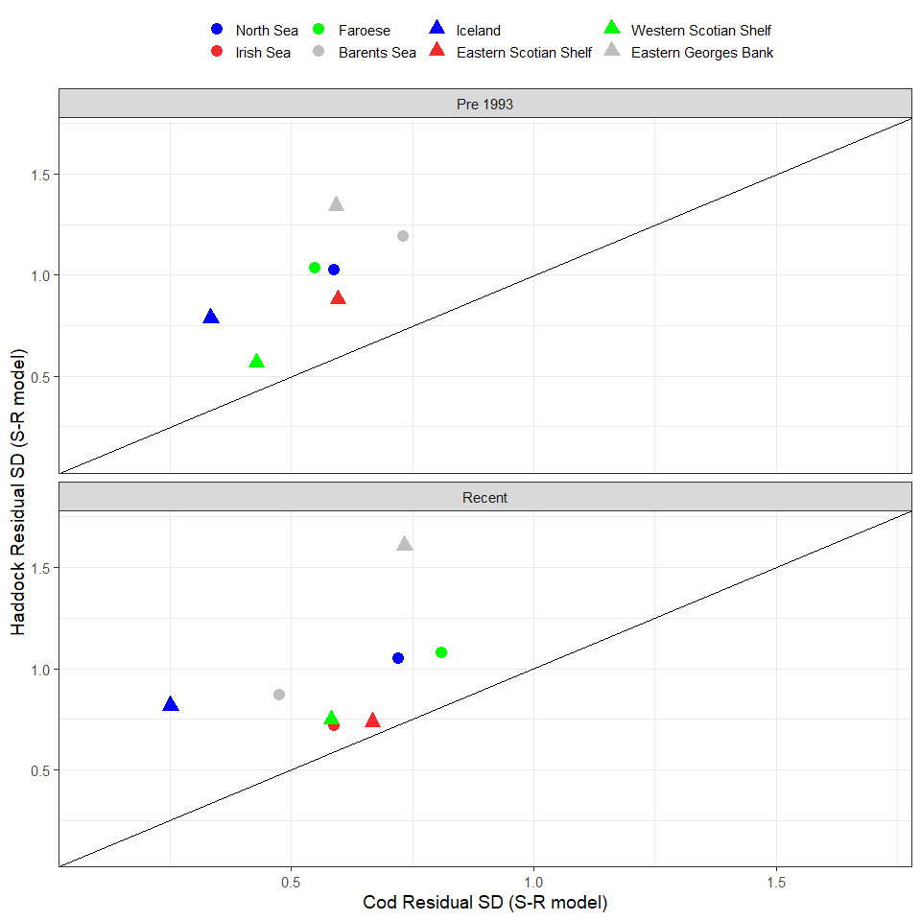

Figure 4. Standard deviation of the log residuals from the Ricker stock recruitment model

* 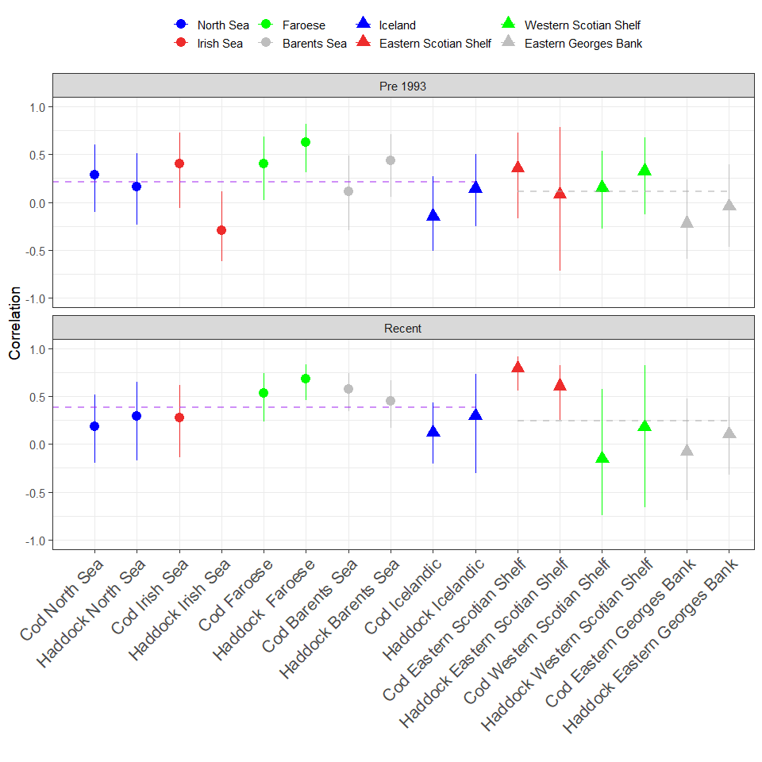
* Figure 5. Autocorrelation of recruitment residuals from Ricker stock recruitment model in each Period. The dashed lines show the average for the North East Atlantic (left) and North West Atlantic (right) stocks. The error bars represent the 95% Confidence Interval.

Figure 6. The log of the maximum annual reproductive rate estimated using the Ricker stock recruitment model for each stock in the Pre-1993 and Recent period with 95% confidence intervals.

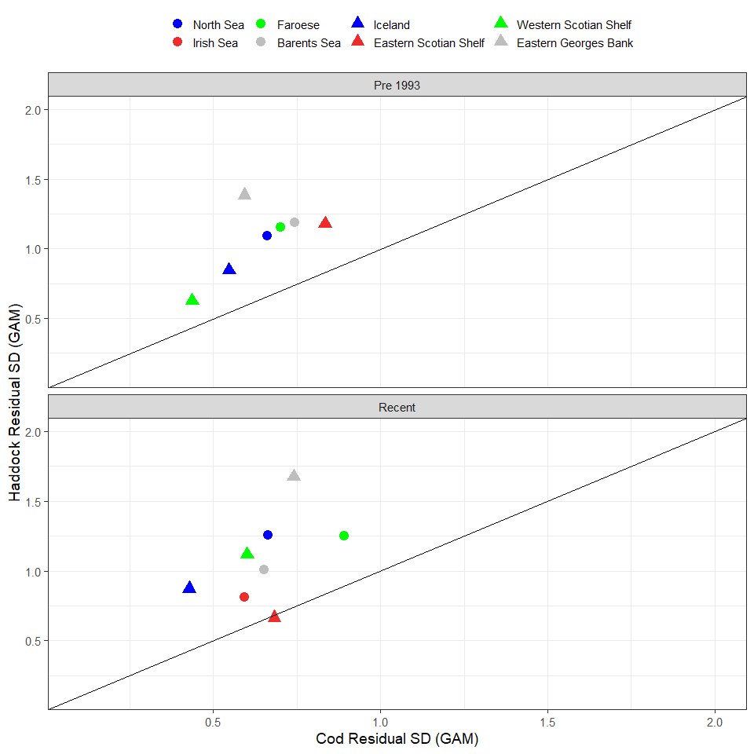

Figure 7. Standard deviation of the log residuals from the Generalized Additive Models (GAMs).

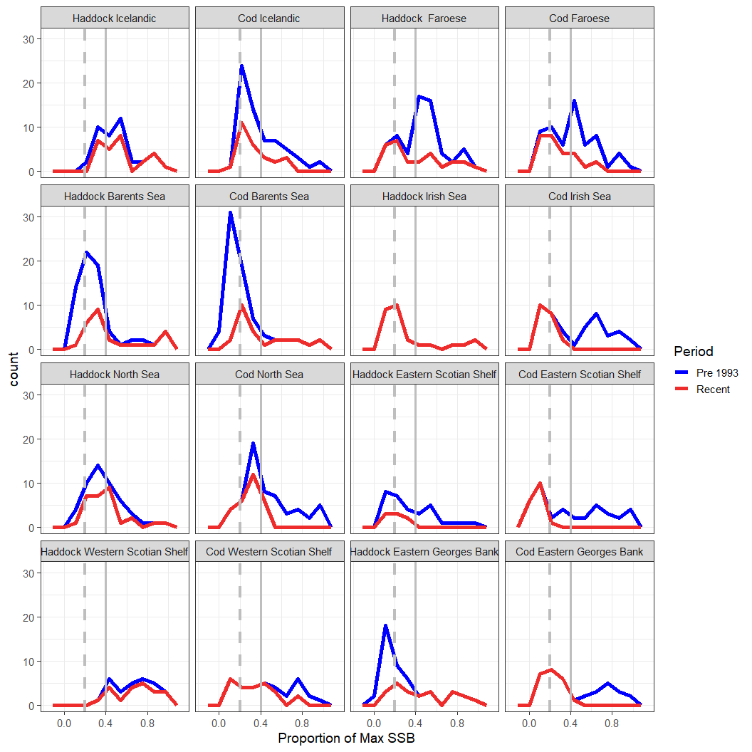

*Figure 8. Density plots of the SSB values by each period as percentage of the maximum for the whole time series. Vertical grey dashed line is 0.2 of maximum SSB while the grey solid vertical line is 0.4. Note that for the cod on the Eastern George Bank and the Western Scotian shelf, in the Pre 1993 period, all SSB values were above 40% of the maximum values.*

Figure 9. The log of the maximum annual reproductive rate estimated using the mean recruitment when SSB is ≤ 0.4 of maximum SSB. The error bars represent 1 standard deviation from the mean. Note that there was insufficient data in the recent period for Western Scotian Shelf Haddock to calculate the standard deviation.

Supplement Figures.

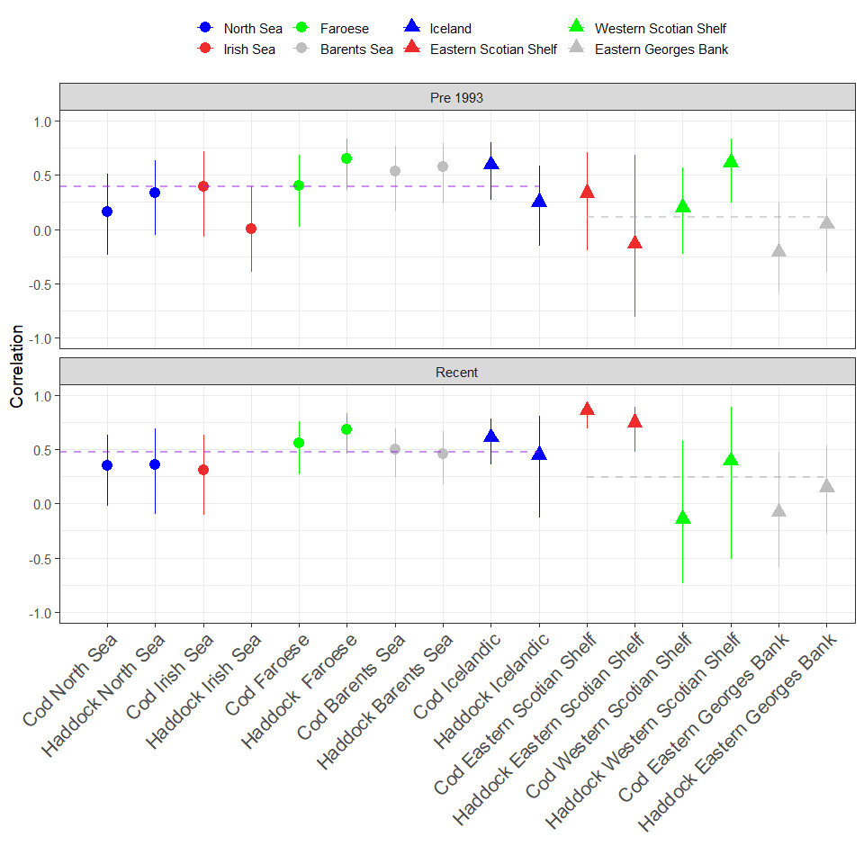

Supplement Figure 1. Autocorrelation of recruitment residuals from GAMs in each Period. The dashed lines show the average for the North East Atlantic (left) and North West Atlantic (right) stocks.

Supplement figure 2. Density plots of the residuals from the Ricker model run for the whole time period for each stock.